# **Deciding what to try next**

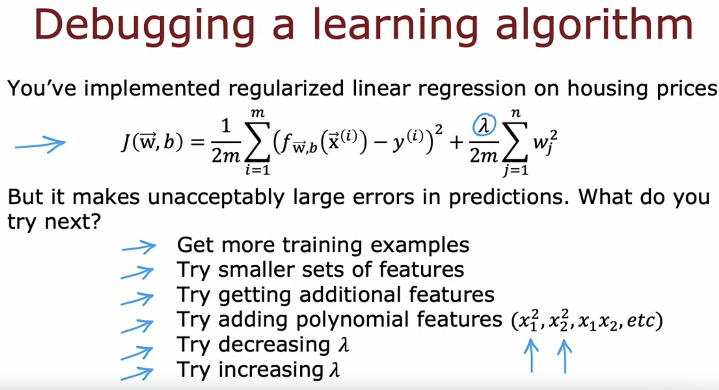

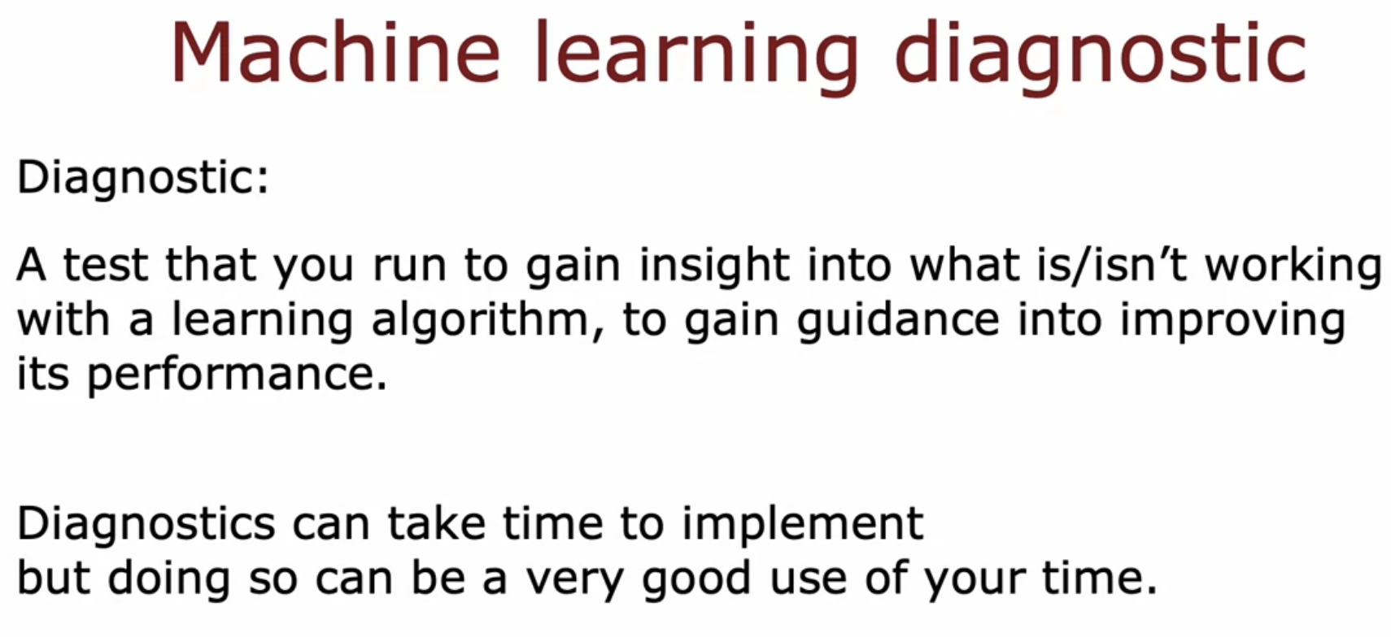

# **Evaluating your Model**

## **Regression Tasks**

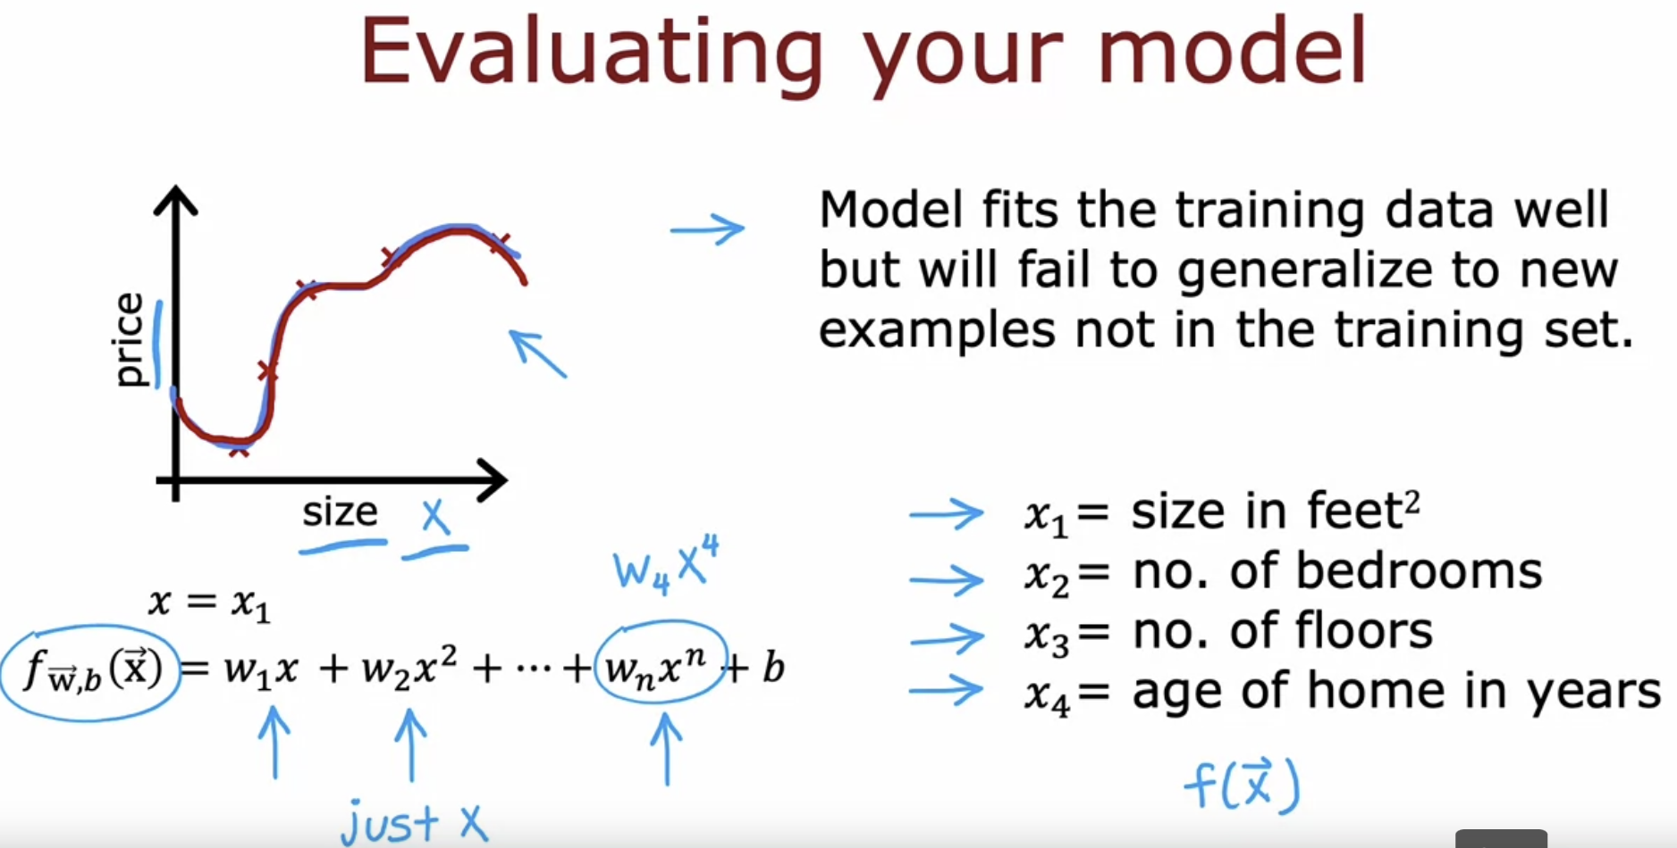

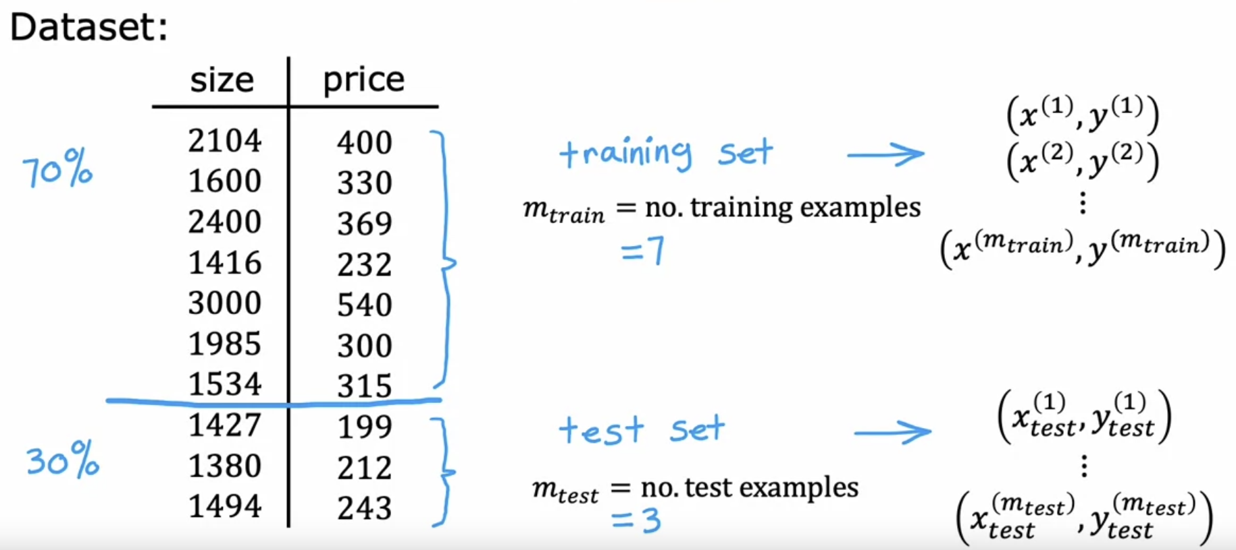

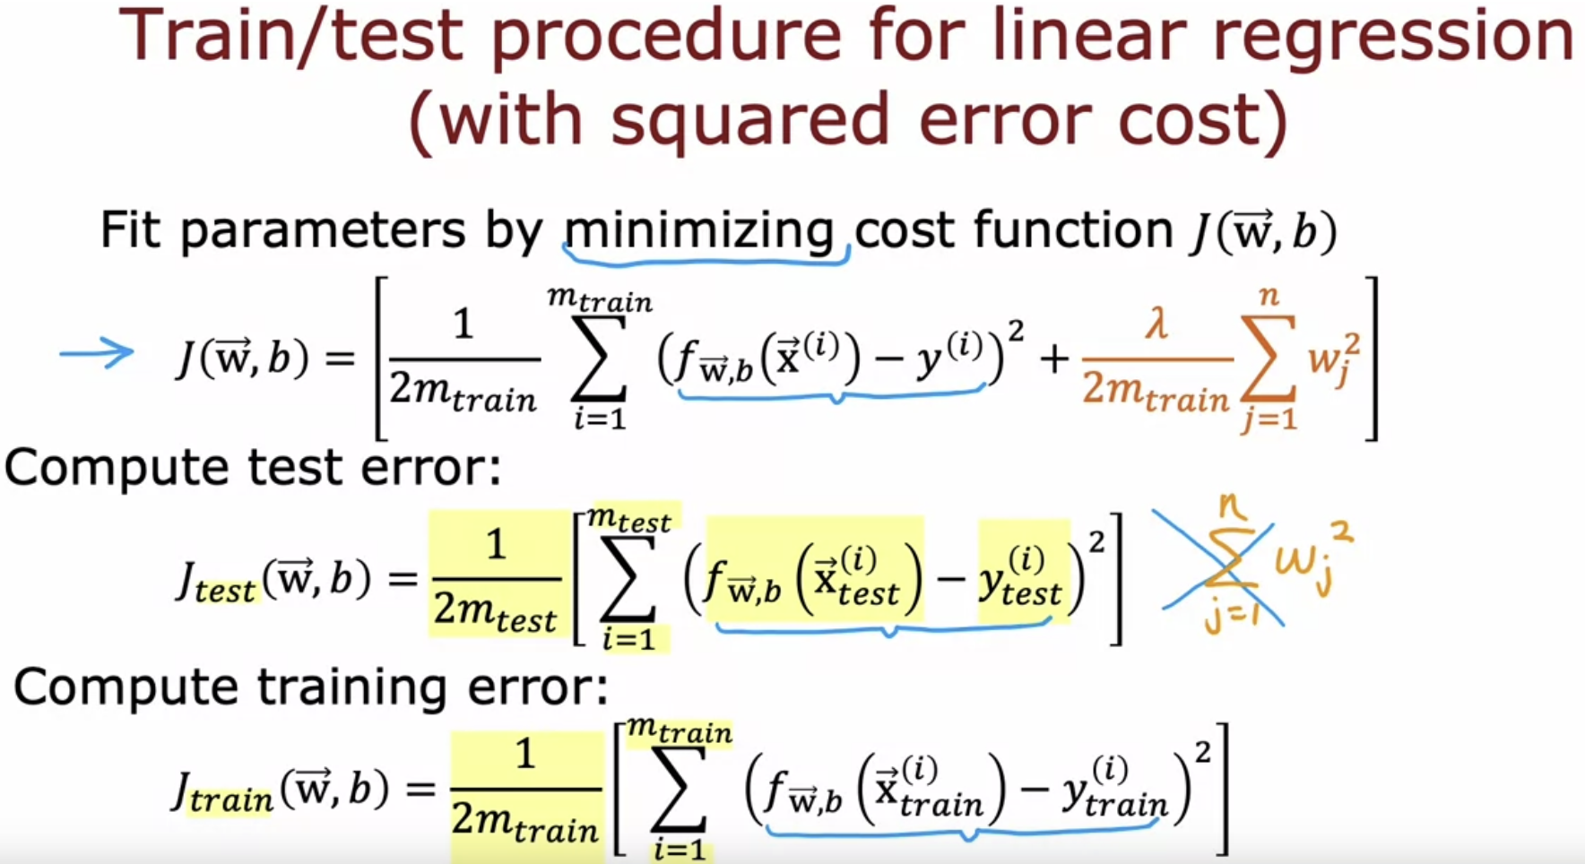

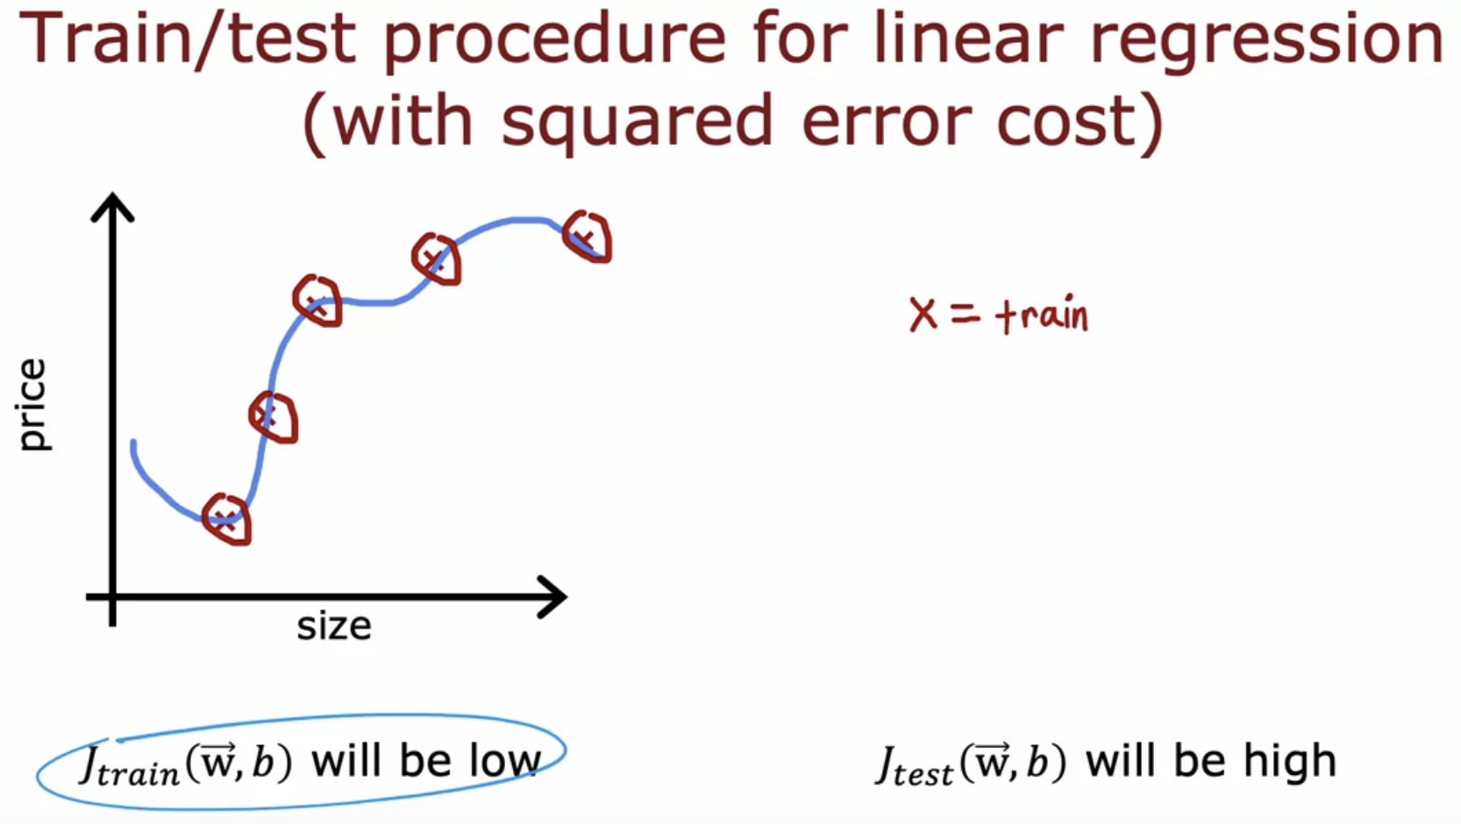

What if the additional test examples are present ???

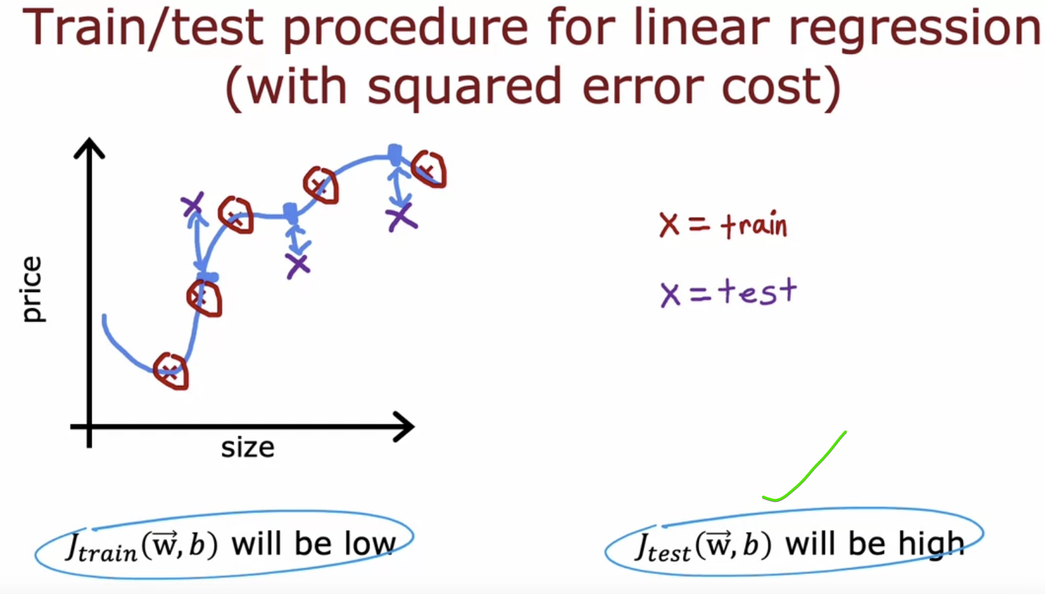

The model is not generalizing well.

## **Classification Tasks**

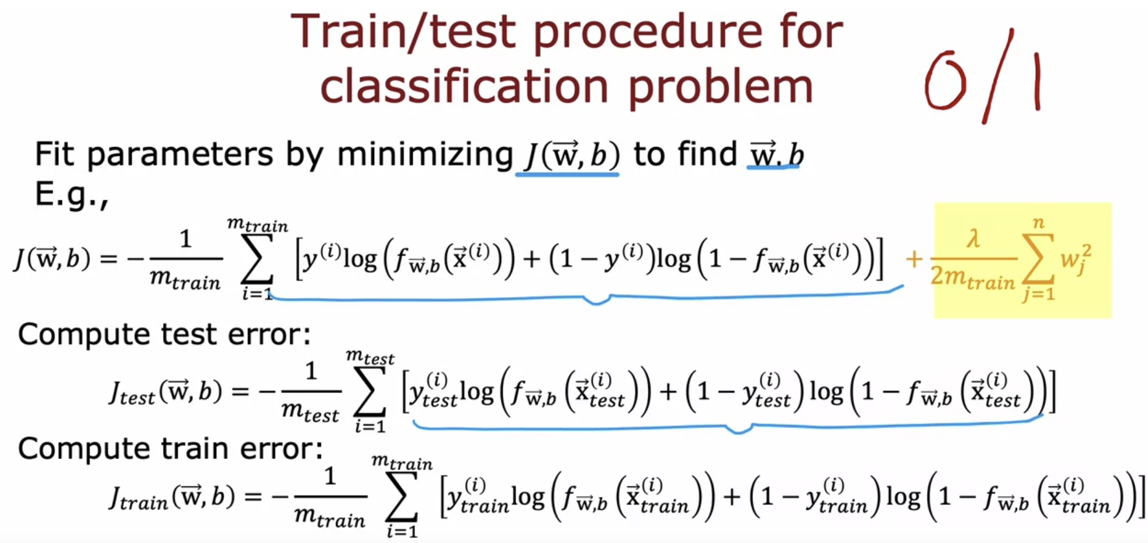

The above procedure can also be done with the help of actual and expected output.  
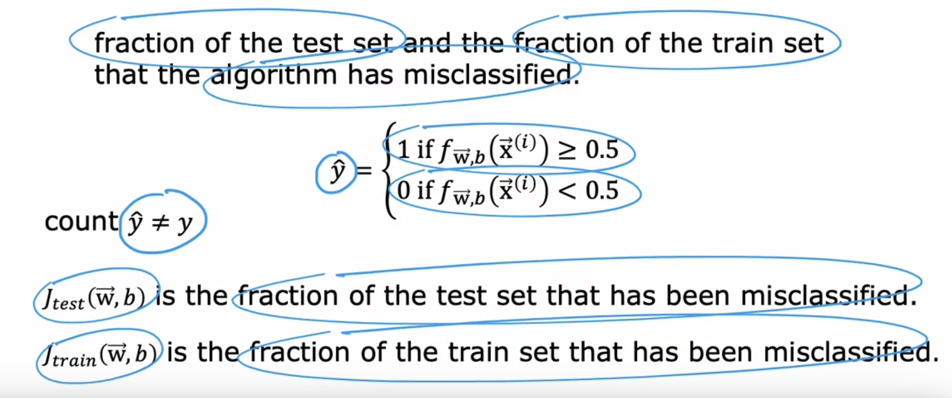

# **Model selection and training/cross validation/test sets**

d -> degree of the polynomial

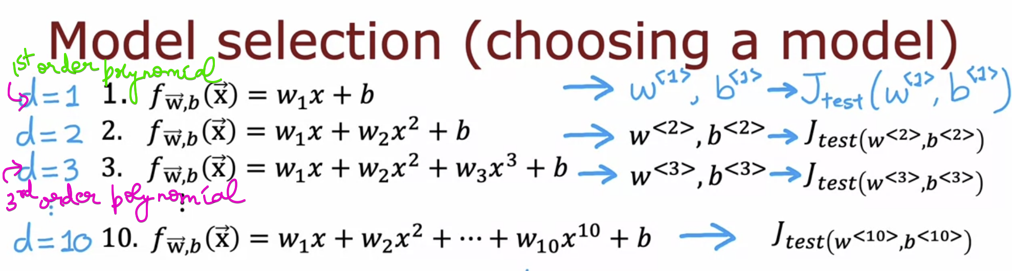

Look for all the J test, and find for which order polynomials does J test is low ???  
Lets consider that for d=5, J test is low. And choose this model for your application.  


But,  
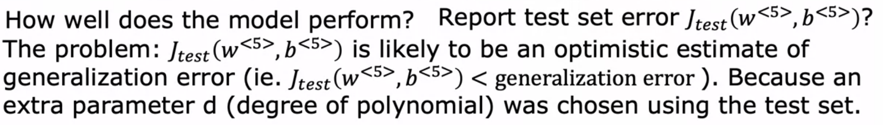

We tested the model’s degree based on the test error and came out of a degree.  
But this performs an overly optimistic since it is tested and chosed based on the test data.

Similarly for training data,   


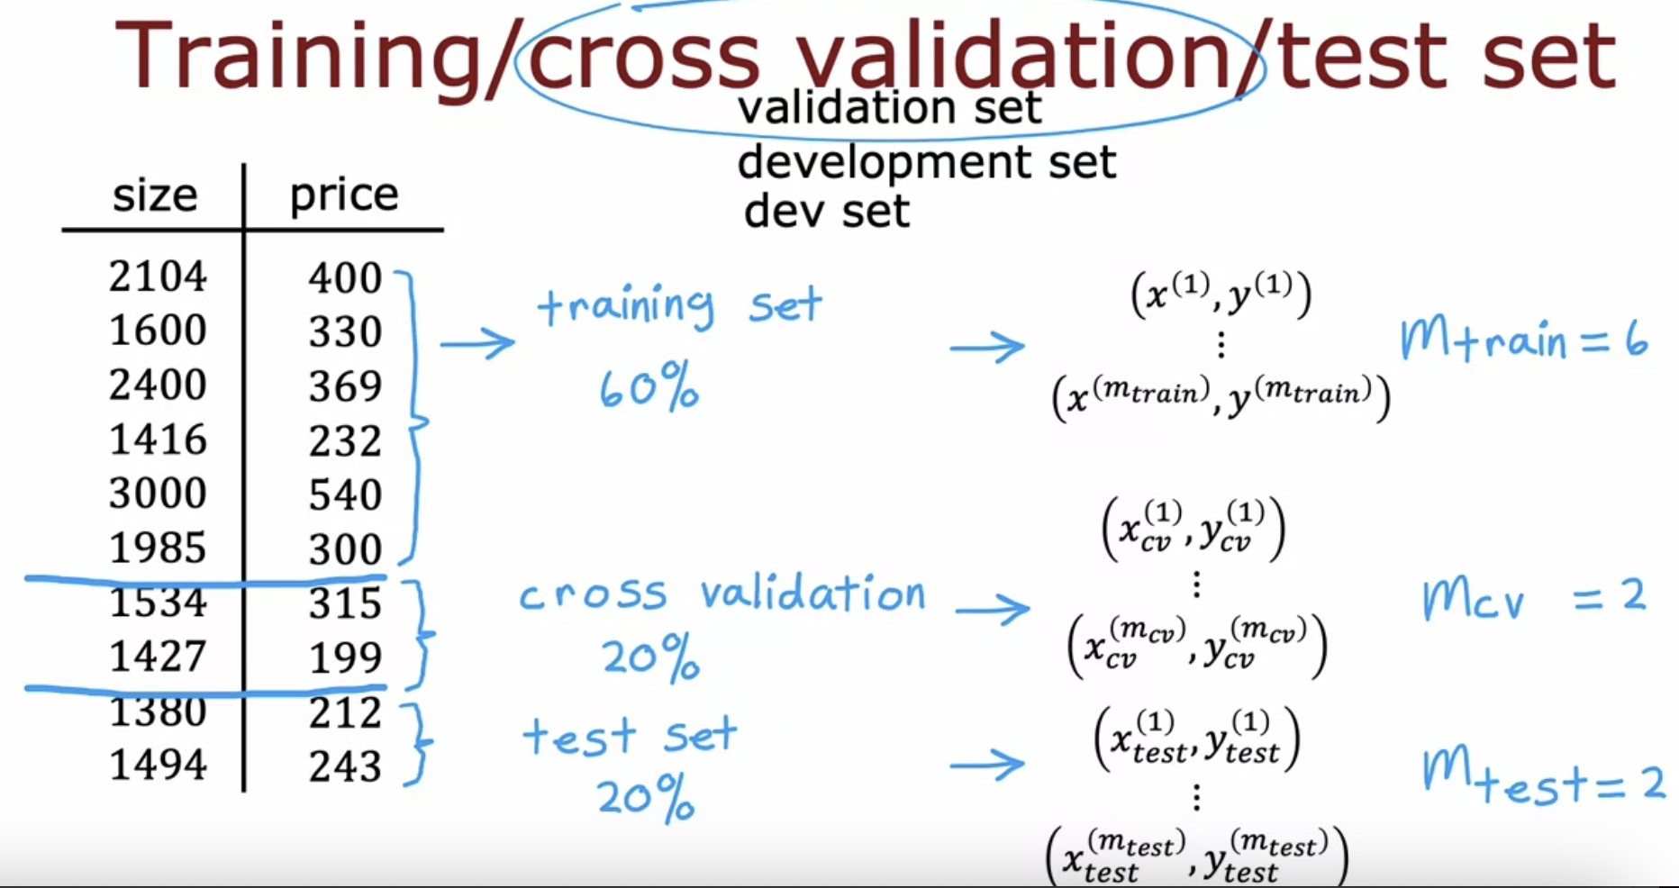

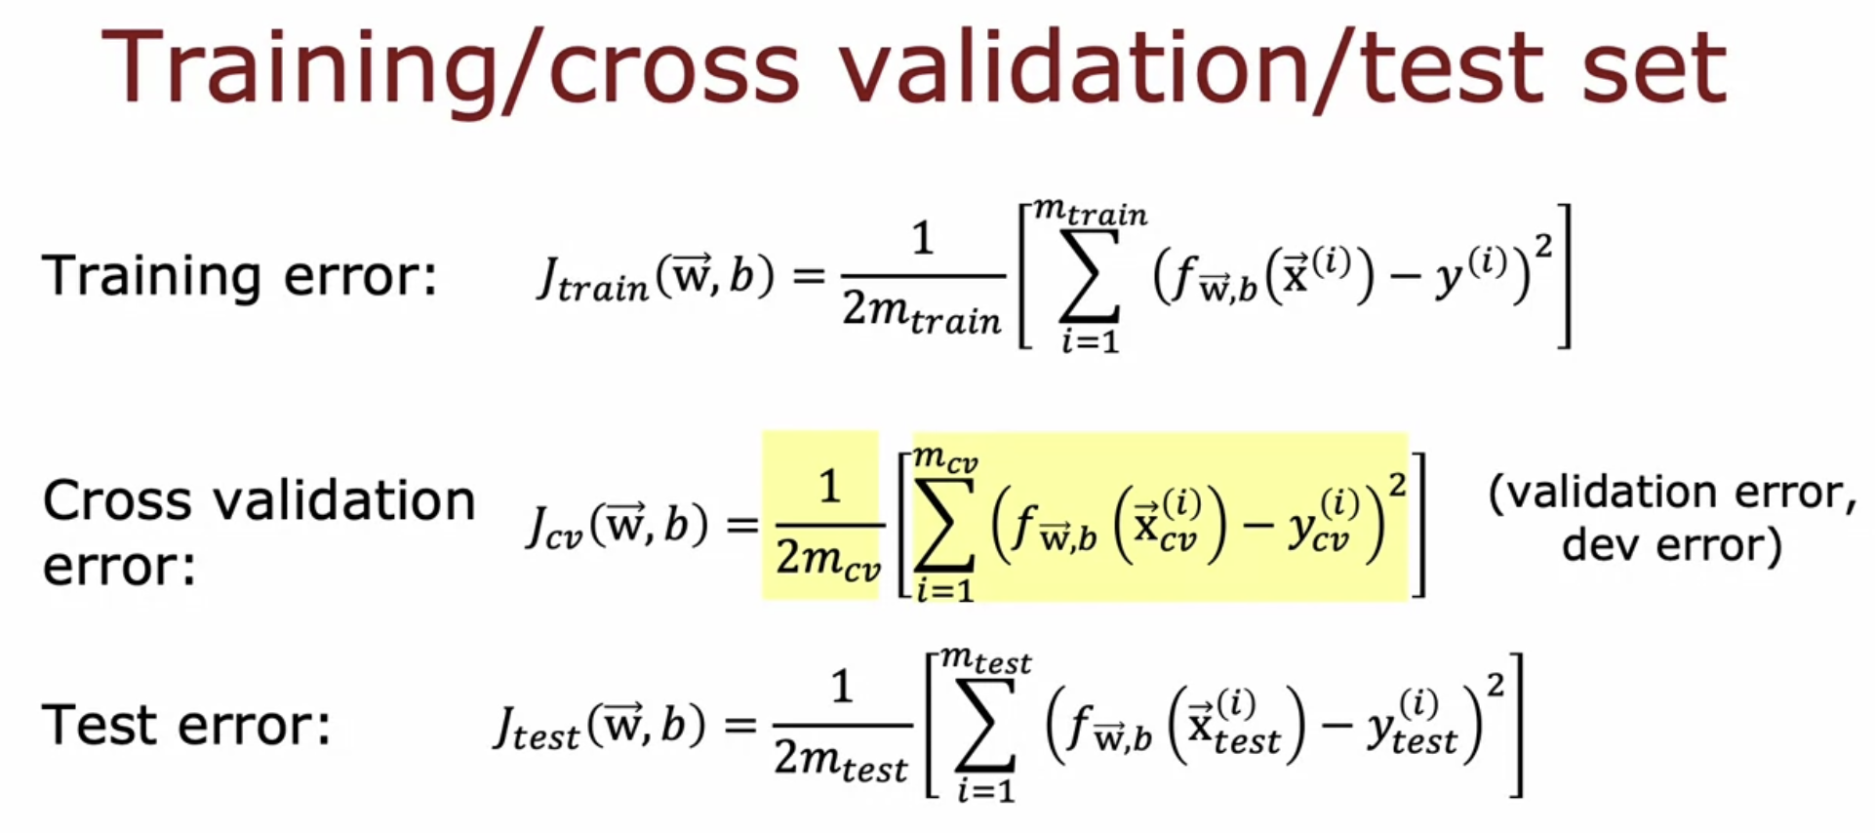

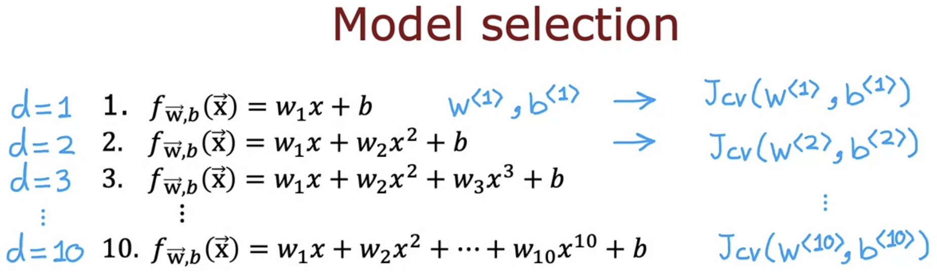

Look for all the J cross-validation, and find for which order polynomials does J cross-validation is low ???  
Lets consider that for d=4, J cross-validation is low. And choose this model for your application.

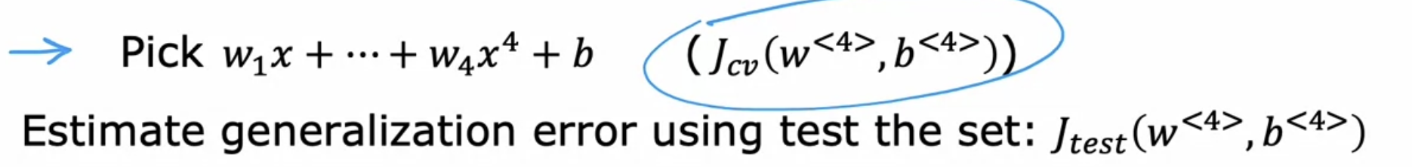

Up-to now the model has not seen the test data.

Here J (test) will be the fair estimate of the generalization error of this model w4, b4

To help us to decide how many layers does our neural network has, and how many hidden units in every hidden layer ???? 🡪 The above technique can be used.  
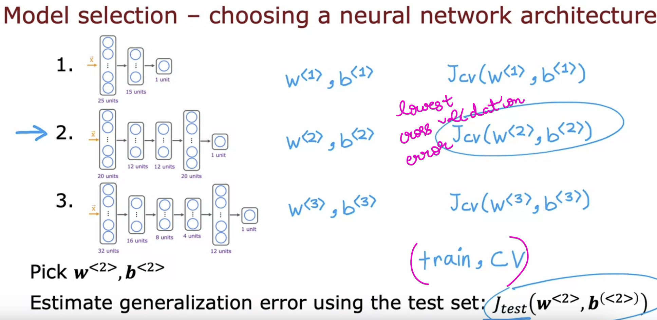

# **Lab 🡪 Model Evaluation and Selection**

Refer Model_Evaluation_and_Selection.ipynb

# **Quiz**

